## Git Repository Report

Using a git repository for collaboration contains several steps and has a different approach.

1. Initializing git repository

Step 1: Create a remote repository on GitHub

Step 2: Create a project on a local device.

Step 3: Initialise project folder as git folder by using ‘git init’ command

: To see the status, use ‘git status’ command

: To see the current branch, use ‘git branch command

Step 4: Make initial commit by using following command:

* Git add -A
* Git commit -m “<message>”

Step 5: connect local project folder to remote git repository by following command:

* Git add remote <remote name> <git codeurl>

Eg: git add remote origin https://github.com/Faithinfotech-Training/Experion-.Net-Team1.git

Step 6: make new branches if needed

* Git checkout -b <branch name>

Eg: git checkout -b Development/AngularUINew

Step 7: Push committed changes to remote repository

* Git push -u -f <remote name> <branch name>

Eg: git push -u -f origin Development/AngularUINew

After step 7 the contents in local project repository will be uploaded to remote repository

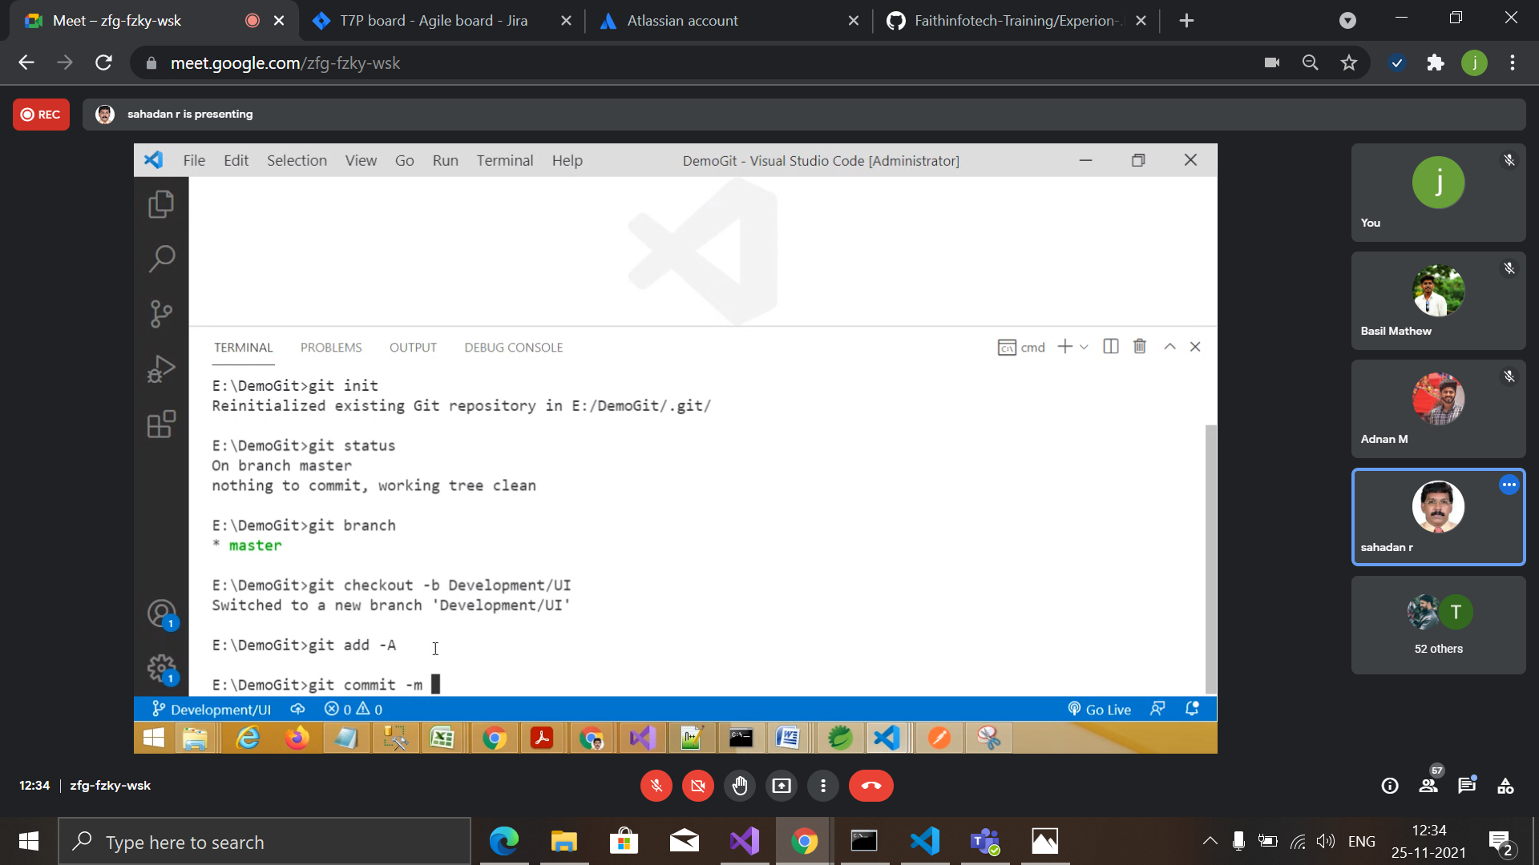

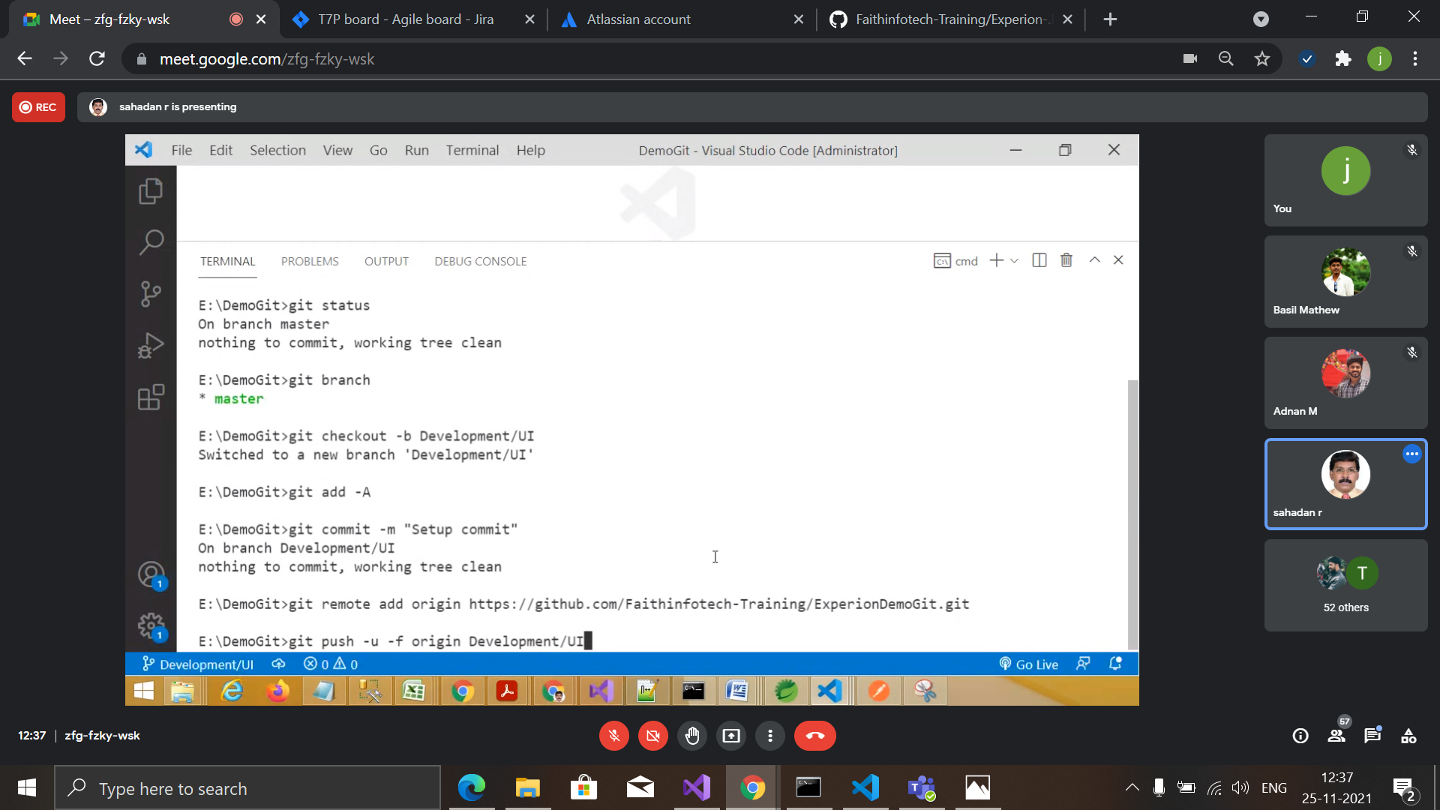

1. Clone and using existing git repository

Step1: Use following command to clone existing remote git repository and use it in local system.

* git clone –b <branch> <url>

Eg: git clone –b Development/AngularUINew <https://github.com/Faithinfotech-Training/Experion-.Net-Team1.git>

Step 2: After making any changes, if you want to upload it to a remote repository use the following commands.

* git add <file name>

or

git add -A

* Git commit -m “<message>”
* Git push <remote name> <branch>

Eg: git push origin Development/AngularUINew

1. After initialising and cloning procedure every time when a user wants to upload their changes they have to take a pull from a remote repository.

* git checkout <branch>

Eg: git checkout Development/AngularUINew

* Git pull

Note: Sometimes git pull will result conflicts in the file so we have to check where the conflict is occurring and resolve the conflict and after all the conflicts are resolved,

Make the changes as staged and commit the changes.

* Git add -A
* Git commit -m ”<message>”